Life is sweet, so why not enter your favorite treat!
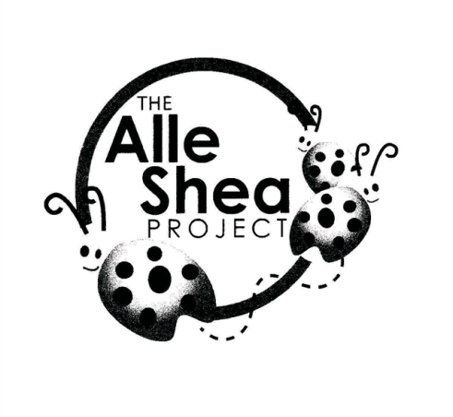

OI Love Dessert & Dance Fundraiser
Dessert Contest
Saturday, October 28th 6-10pm
Point Pleasant Fire Hall ~ Irondequoit, NY

DESSERT CONTEST RULES
- Participants may enter one dessert
- All entries need to include a copy of the recipe (or ingredients) and the entry form
- Entries will be judges on appearance and taste
- Only dessert that do not require refrigeration will be accepted
- Entries will be accepted up to 7:00 pm
- Prize ribbons will be rewarded for the top 3 desserts
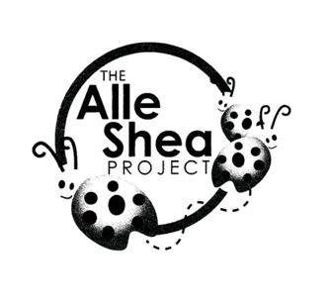
Dessert Contest
Entry Form
Entries may be brought into Point Pleasant Fire Hall (Irondequoit)
Saturday, October 28th beginning at 6pm
Entries MUST include either a copy of the recipe or a list of ingredients. Please make NOTE if your dessert is sugar free, nut free, gluten free or contain peanut butter/nuts.
Name: _____________________________________________________
Phone Number: ______________________________________________
Name of dessert: _____________________________________________
Recipe (or list of ingredients) ________________________________________________________________________________________________________________________________________________________________________________________________________________________________________________________________________________________________________________________________________________________________________
Special Instructions
____________________________________________________________
Say something interesting about this dessert
________________________________________________________________________________________________________________________

